HOME BUDGET APP:

I have created Home Budget App by using React-native, Redux ,Redux Persist(used for data persisting(remaining) even after app is closed and refreshed),React-Native-CLI, scrollView for scrolling ,Android Studio, Visual Studio Code.

There are two screens mainly:

Budget Entry and Budget Entry Listing:

Budget Entry:

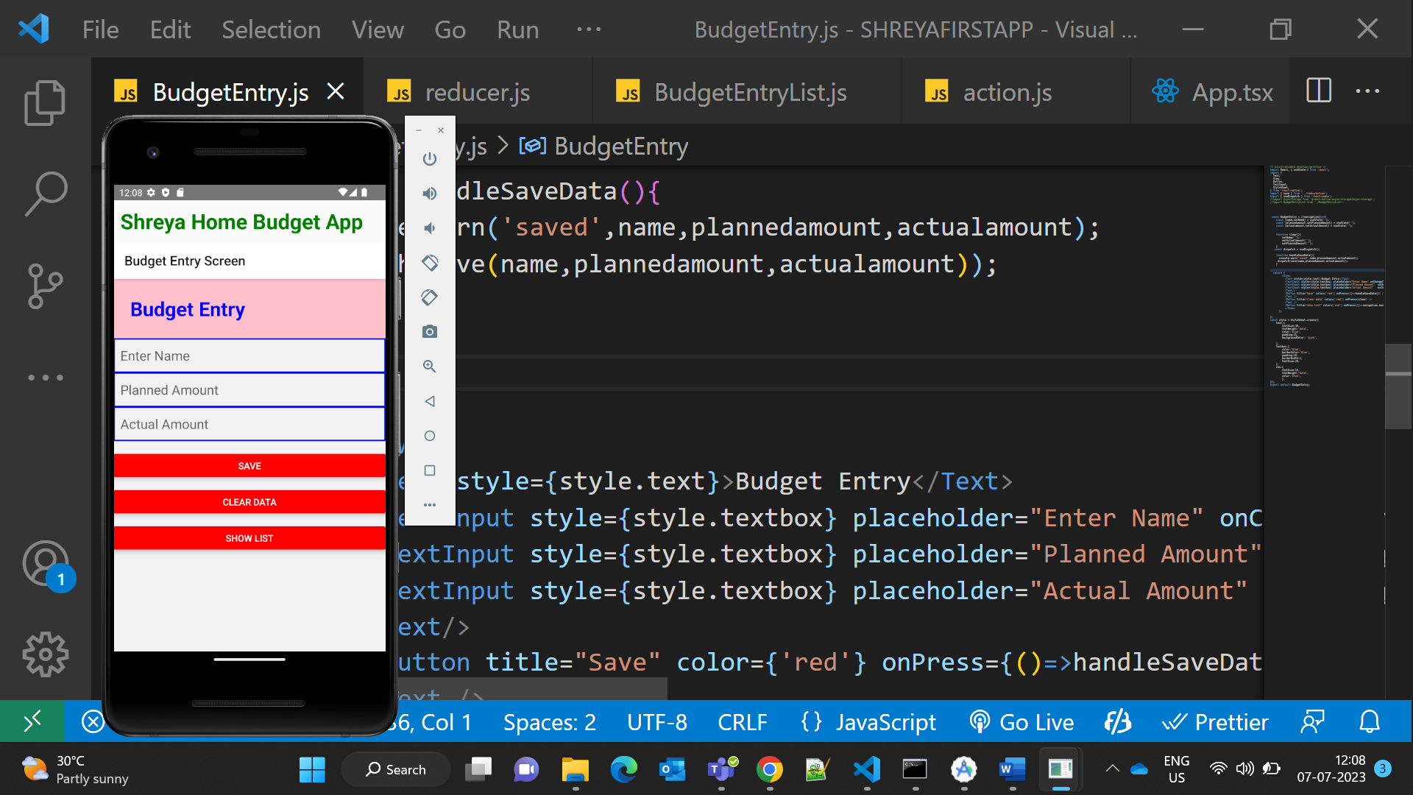

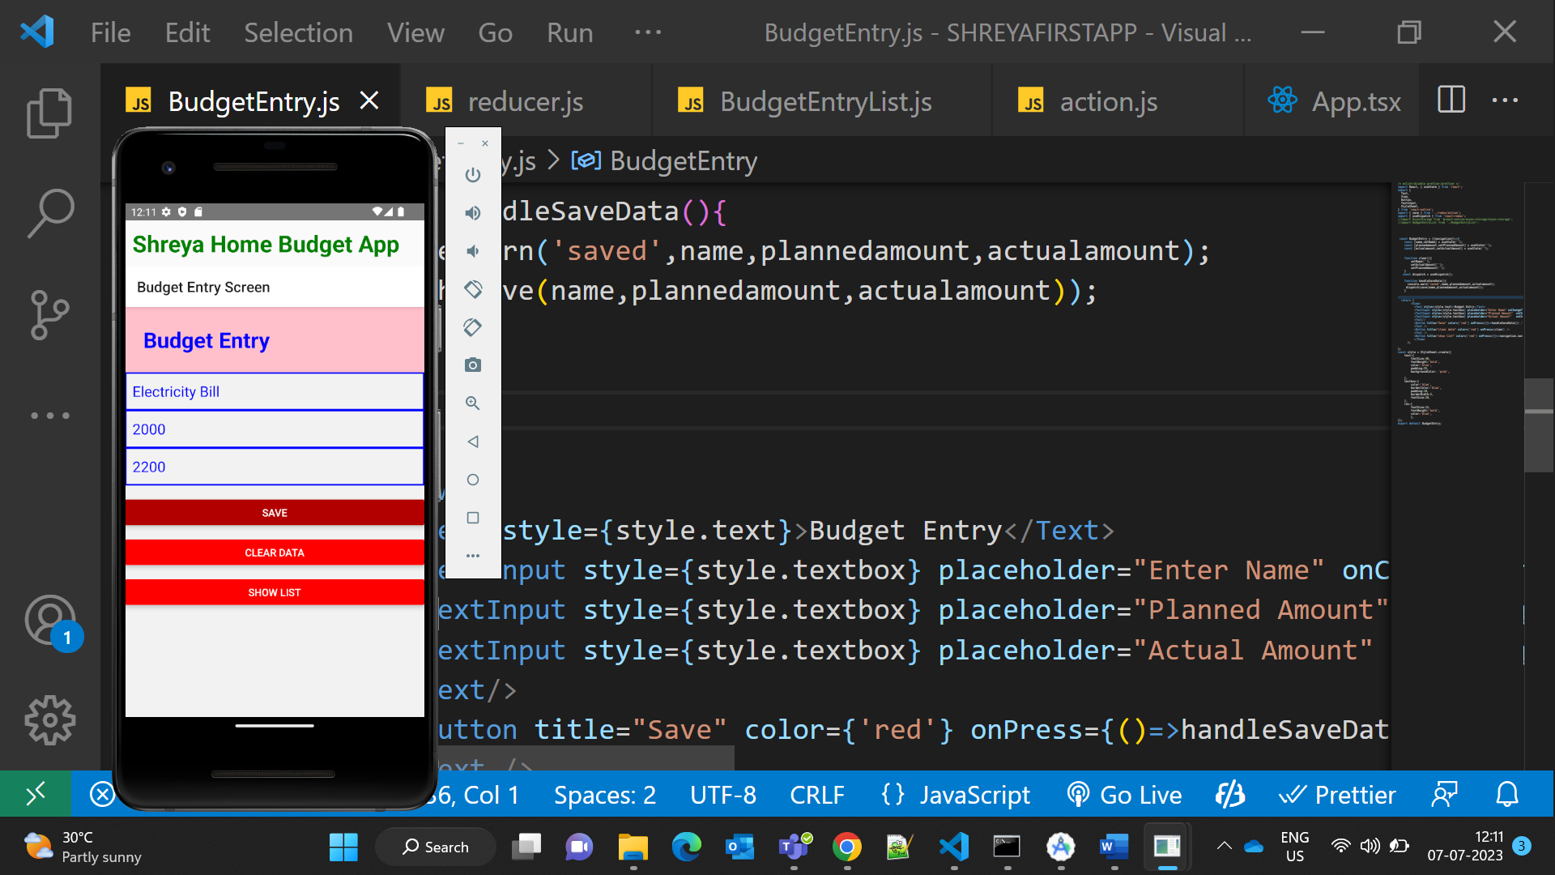

Data Saved

Console data

Action

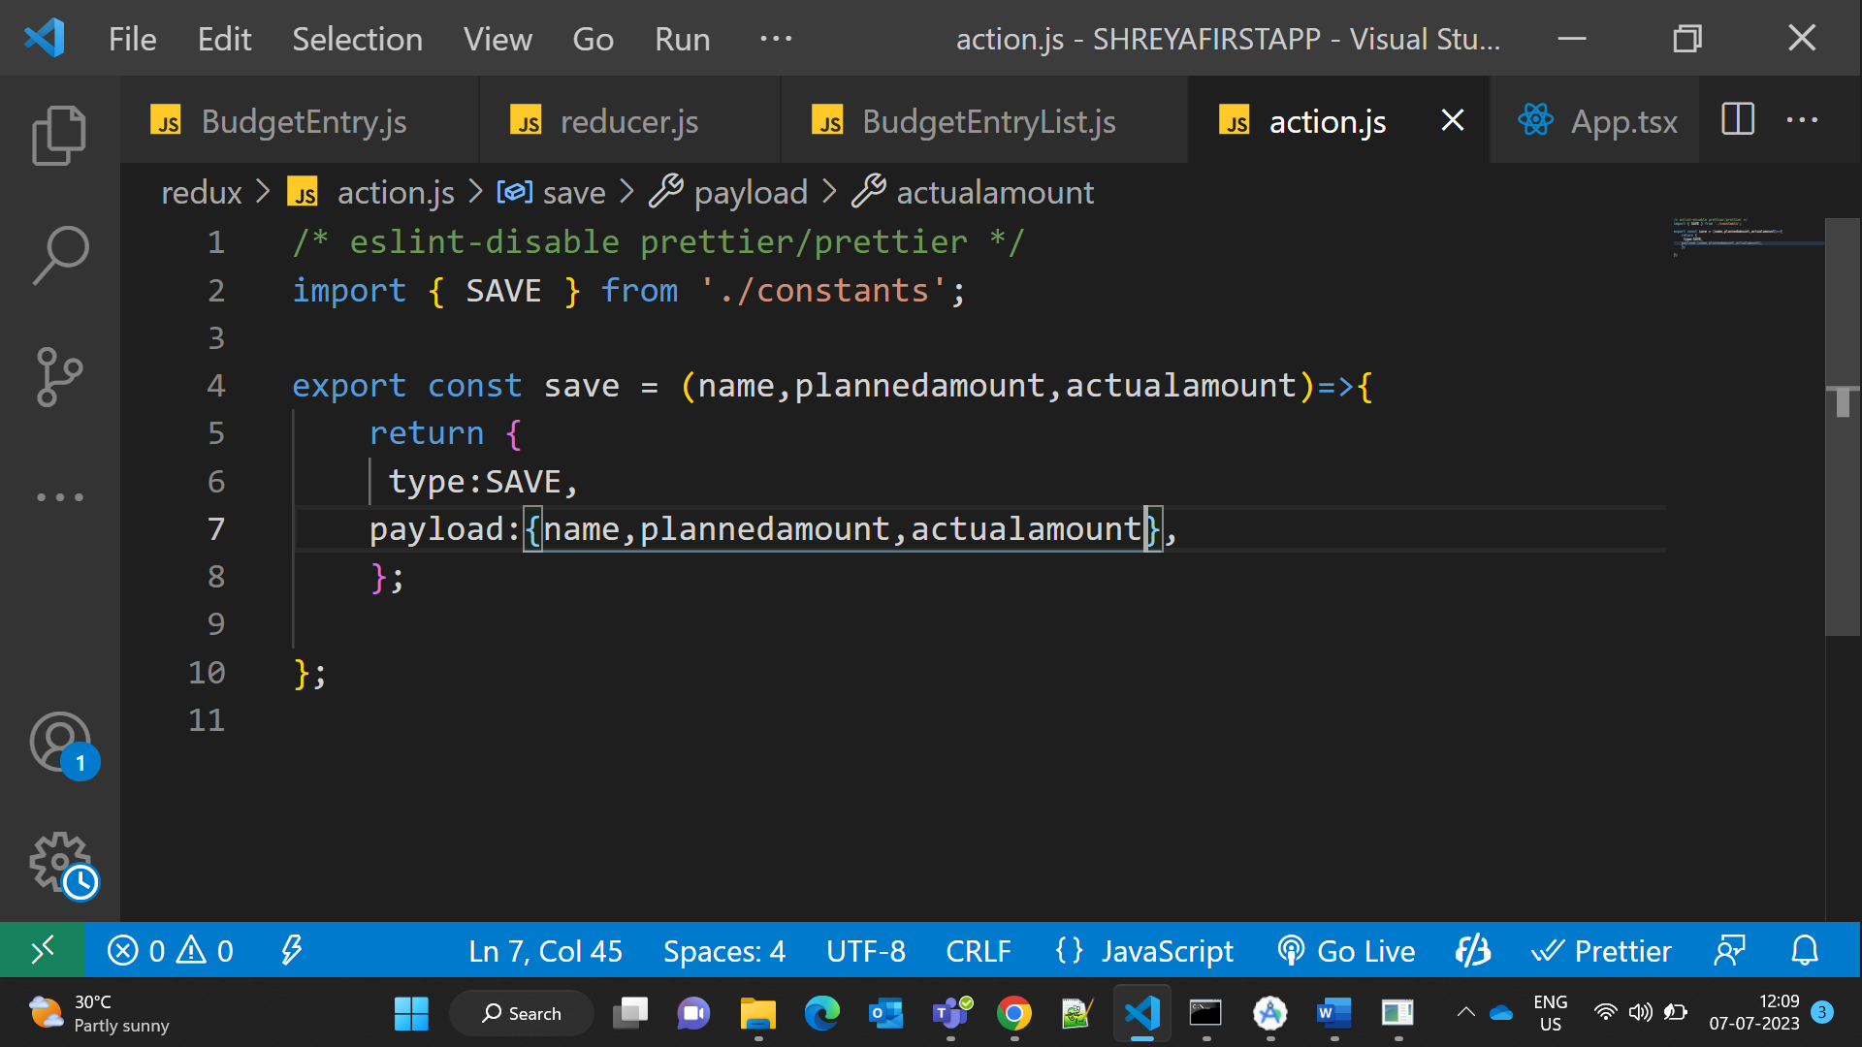

Reducer

Store

Done Validation Like Keyboard type=’number’ in amount fields:

BudgetEntryListing Screen:

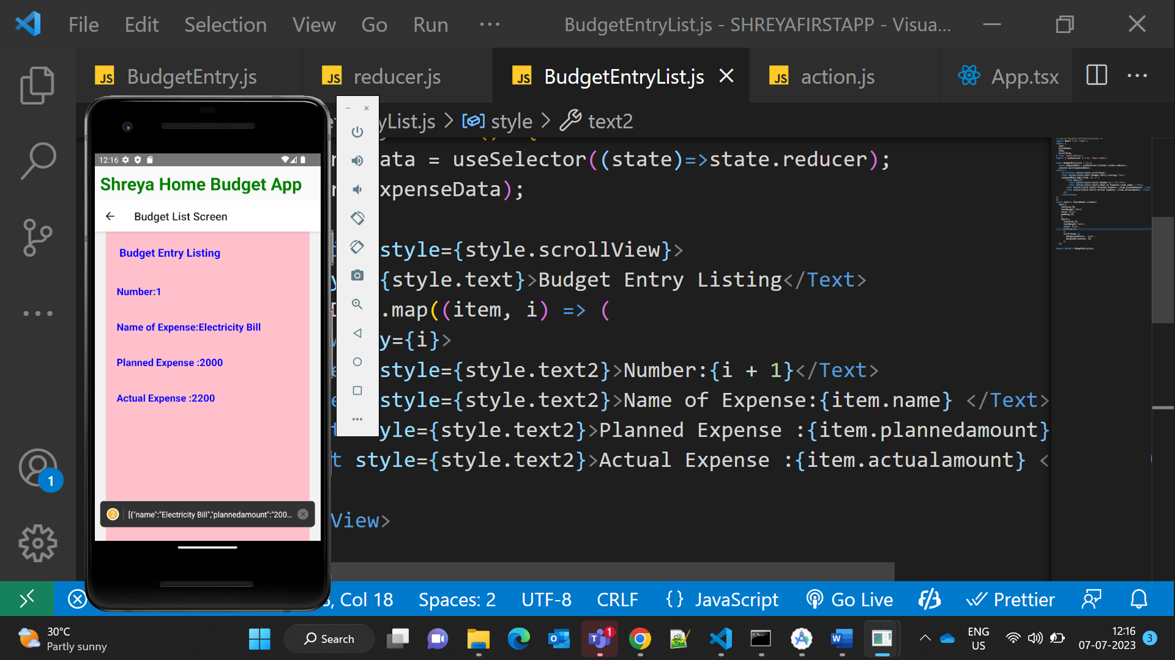

Back Navigation

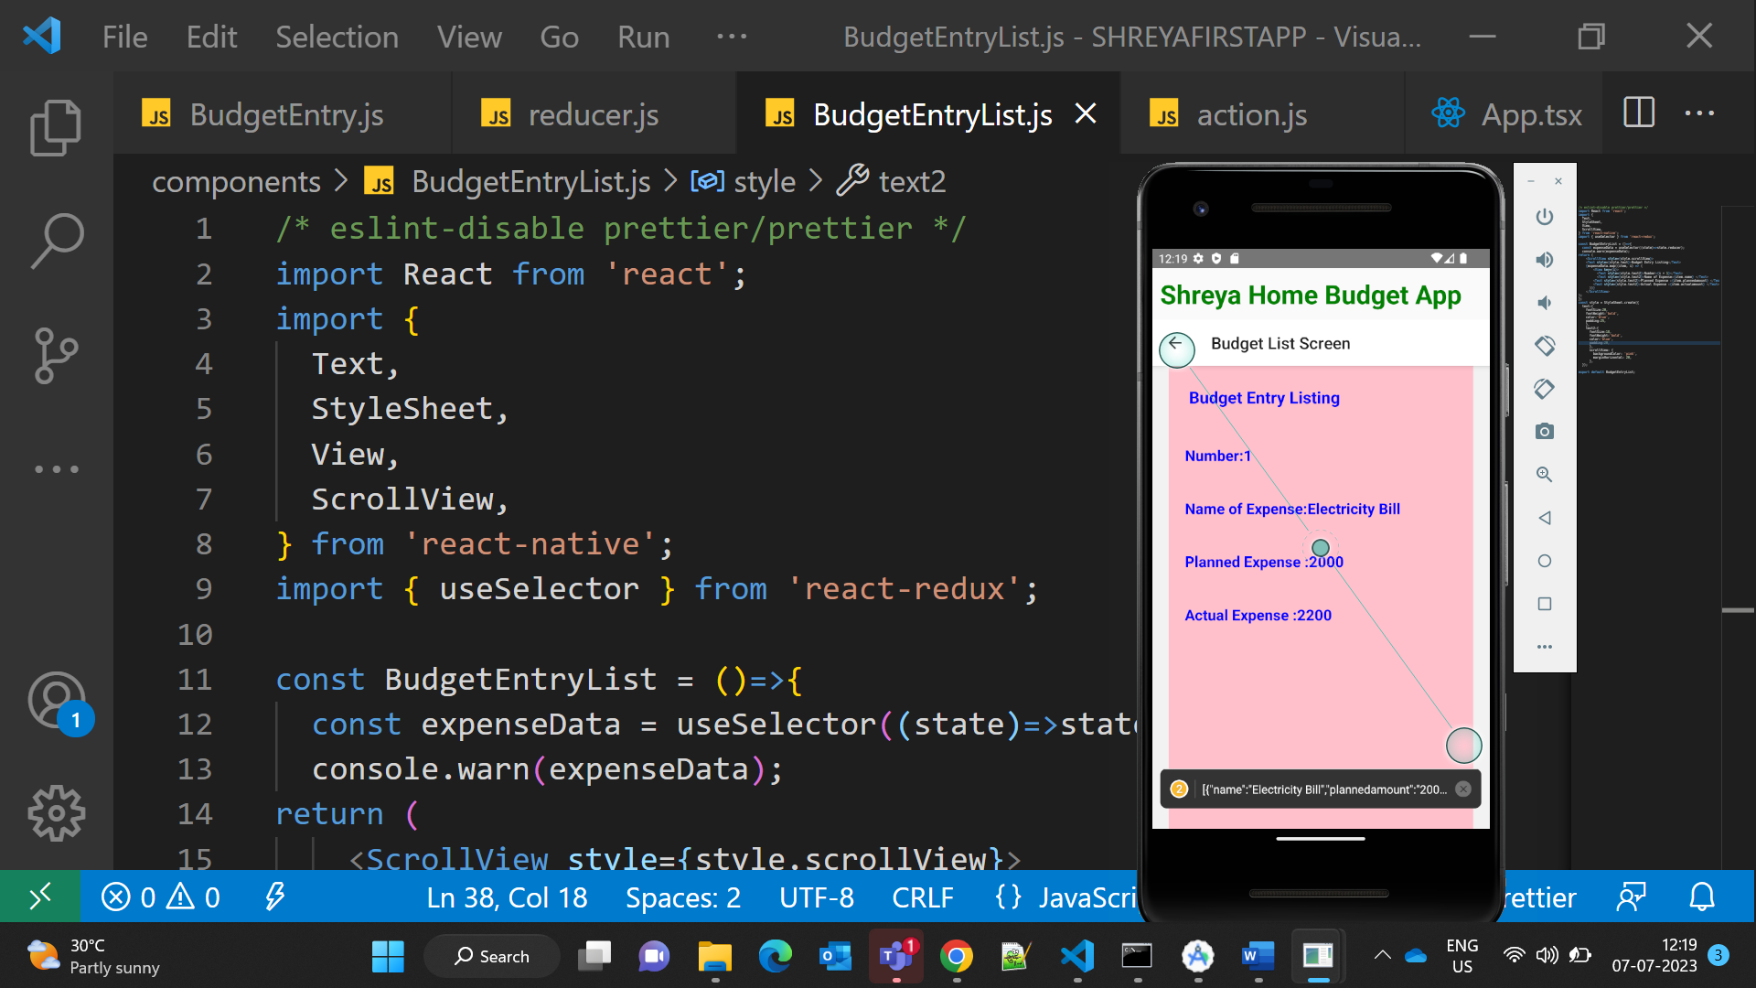

Clear Data:

-------- ---------- End of File--------------------------------------------